ACKNOWLEDGEMENT TAKEN IN NEW YORK STATE  State of New York, County of , ss:  On the day of in the year , before me, the undersigned, personally appeared , personally known to me or proved to me on the basis of satisfactory evidence to be the individual(s) whose name(s) is (are) subscribed to the within instrument and acknowledged to me that he/she/they executed the same in his/her/their capacity(ies), and that by his/her/their signature(s) on the instrument, the individual(s), or the person upon behalf of which the individual(s) acted, executed the instrument.  _____________________________________________  NOTARY PUBLIC  ACKNOWLEDGEMENT BY SUBSCRIBING WITNESS TAKEN IN NEW YORK STATE  State of New York, County of , ss:  On the day of in the year , before me, the undersigned, a Notary Public in and for said State, personally appeared , the subscribing witness to the foregoing instrument, with whom I am personally acquainted, who, being by me duly sworn, did depose and say that he/she/they reside(s) in (if the place of residence is in a city, include the street and street number if any, thereof); that he/she/they know(s)  to be the individual described in and who executed the foregoing instrument; that said subscribing witness was present and saw said execute the same; and that said witness at the same time subscribed his/her/their name(s) as a witness thereto.  _____________________________________________  NOTARY PUBLIC | ACKNOWLEDGEMENT TAKEN IN NEW YORK STATE  State of New York, County of , ss:  On the day of in the year , before me, the undersigned, personally appeared , personally known to me or proved to me on the basis of satisfactory evidence to be the individual(s) whose name(s) is (are) subscribed to the within instrument and acknowledged to me that he/she/they executed the same in his/her/their capacity(ies), and that by his/her/their signature(s) on the instrument, the individual(s), or the person upon behalf of which the individual(s) acted, executed the instrument.  _____________________________________________  NOTARY PUBLIC  ACKNOWLEDGEMENT TAKEN OUTSIDE NEW YORK STATE  State of , County of , ss:  On the day of in the year , before me, the undersigned personally appeared personally known to me or proved to me on the basis of satisfactory evidence to be the individual(s) whose name(s) is (are) subscribed to the within instrument and acknowledged to me that he/she/they executed the same in his/her/their capacity(ies), that by his/her/their signature(s) on the instrument, the individual(s) or the person upon behalf of which the individual(s) acted, executed the instrument, and that such individual make such appearance before the undersigned in the (add the city or political subdivision and the state or country or other place the acknowledgement was taken).  _____________________________________________  NOTARY PUBLIC
Warranty Deed  TO  Title No. | COUNTY:  TOWN/CITY:  PROPERTY ADDRESS:  SECTION:  BLOCK:  LOT:  RETURN BY MAIL TO:
DISTRIBUTED BY

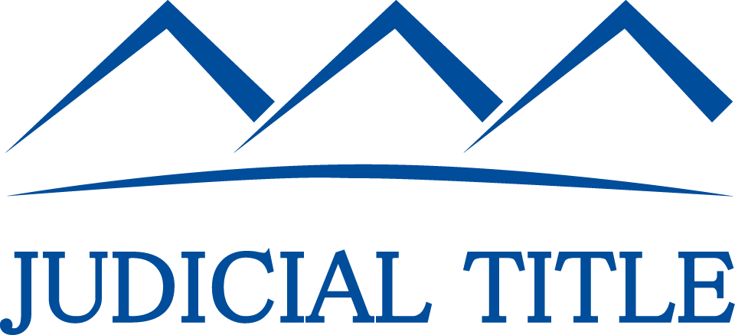

T: 800-281-TITLE F: 800-FAX-9396

